Task : Pods and Services in Kubernetes Deployment

* Create ec2 instance with type t2.micro

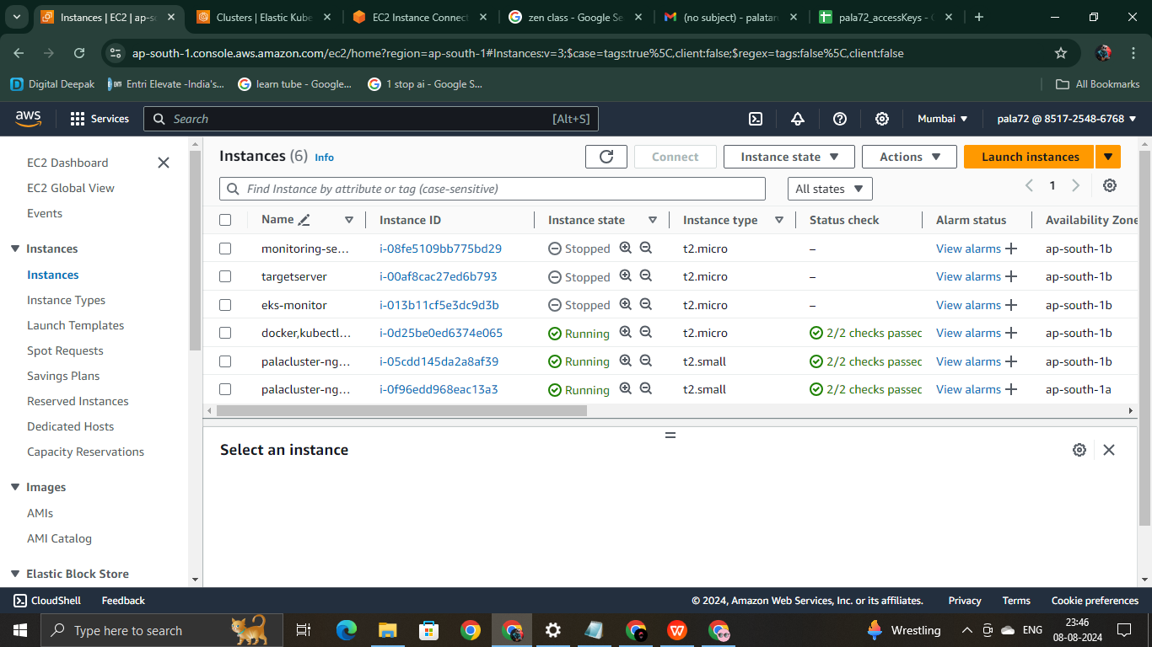

* Update the packages and install docker,kubectl,eksctl
* Open security port 80, 443, 8080.

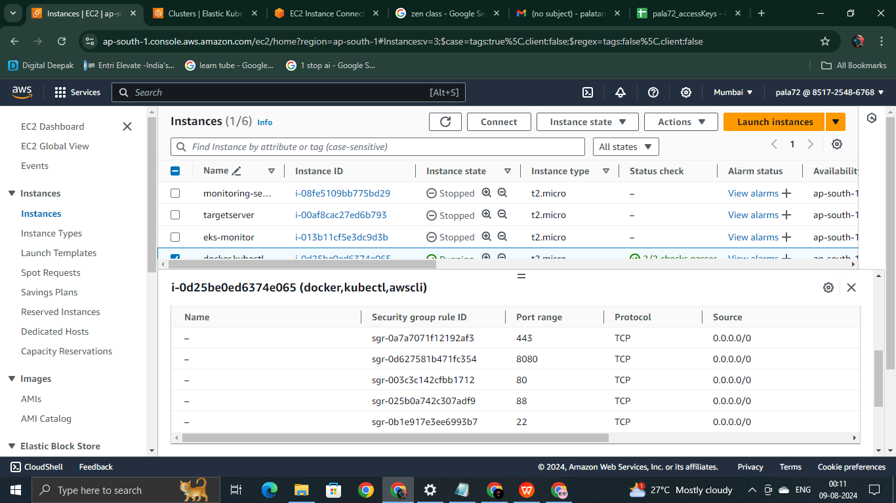

* create a eks cluster with the cluster create syntax

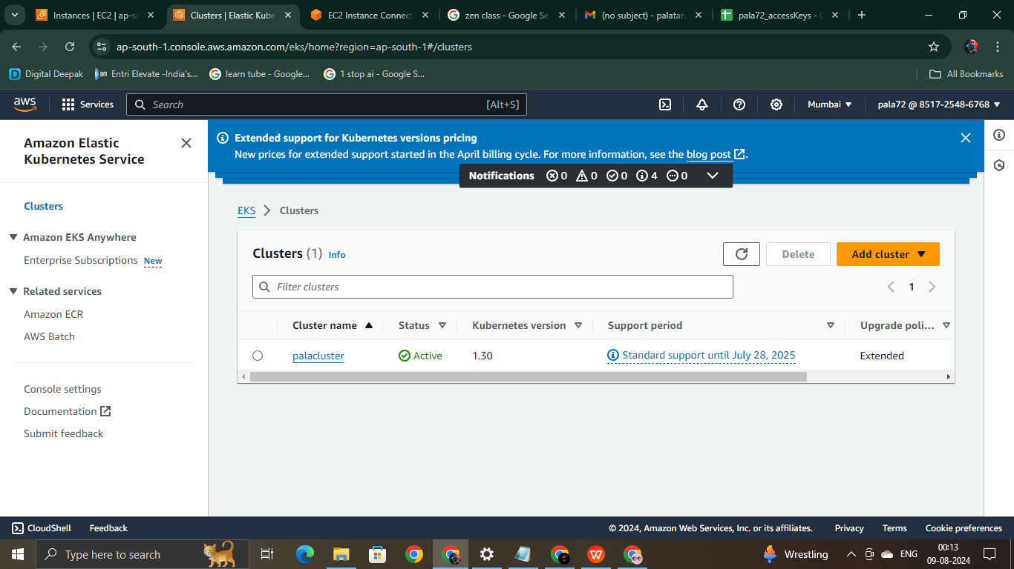

* Also configure your AWS cli by giving the access key, secret key, default region, File name.

Next give details for your application. I am using a simple python flask application

Create a file called app.py using vi editor and save it. Create a Docker file and login using credentials

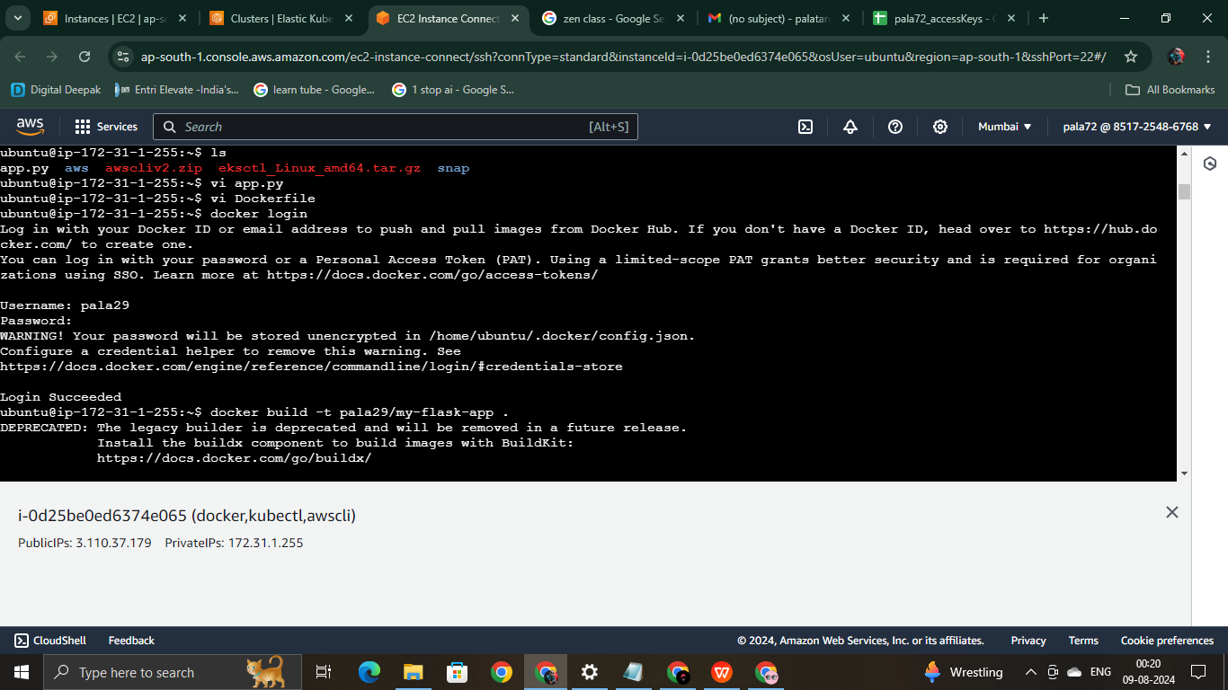

Do docker build and docker push by giving correct name to it

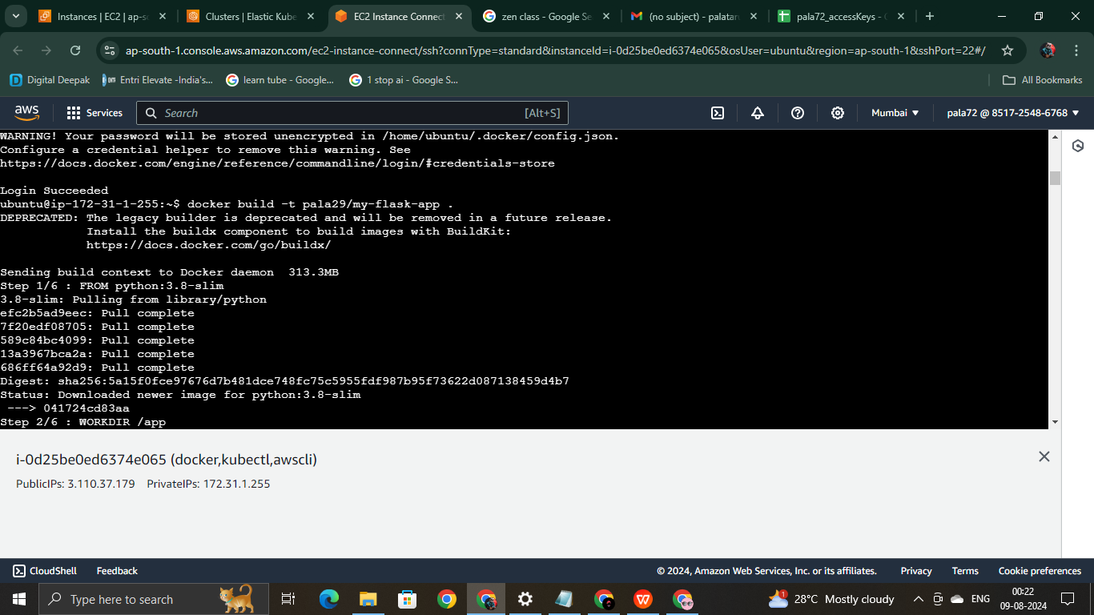

Next two files deployment.yaml and service.yaml

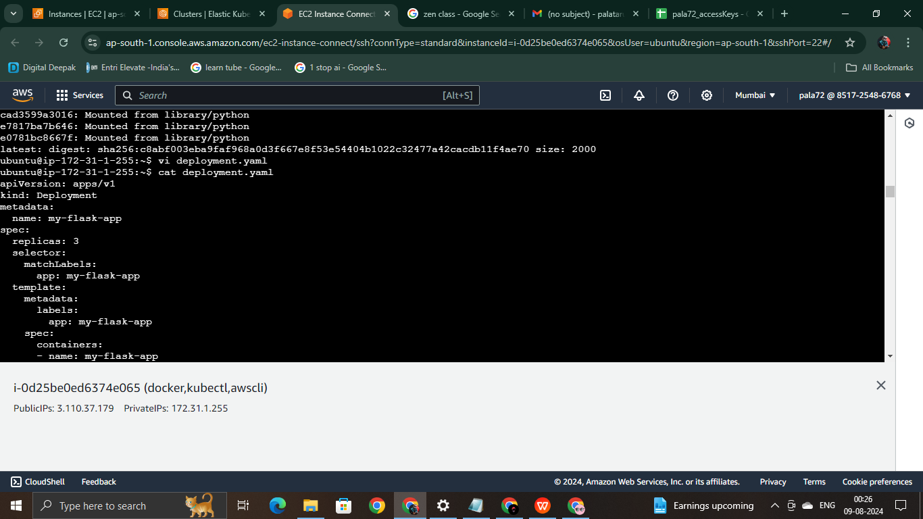

Deploy the application with the deploy command.

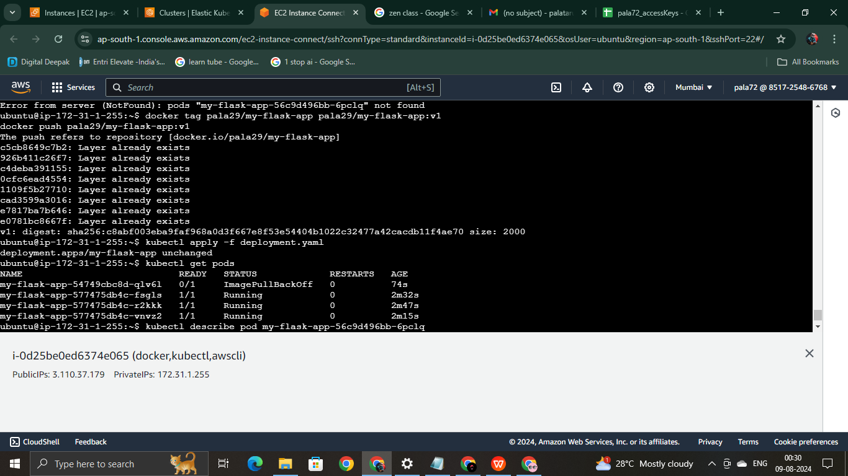

that’s it next open your external IP so the application runs.